CYBERBULLYING AUTO-IDENTIFICATION ON SOCIAL MEDIA USING LONG SHORT-TERM MEMORY

# Abstract

Bullying of any form is frowned at, because of the physical, mental, emotional detriments, bullying online is not exempted, regardless of the fact that perpetuators and victims are often miles apart by proximity; the effects still manifest, destabilising victims. Cyberbullying is the easiest form of bullying as many times perpetuators cannot be held accountable because they cannot be caught; this is a dilemma. Slow response to handling cyberbullying or long fact-checking processes that may not validate a victim’s complaint in the end are just some of the problems with the status quo. We contribute to solving the problem of cyberbullying on social media through the utilisation of Machine Learning in the detection of cyberbullying instances from social media interactions via text and images.

Many researchers have focused on detecting cyberbullying from just text data and only few studies have actually digressed to multimodal forms of cyberbullying detection which could include visual and audio content. Cyberbullying occurs in all media file formats and being able to identify patterns in each format greatly increases the chances of solving the problems of cyberbullying.

Our major contribution is the multimodal system of our detection model and the hybridization of the Machine Learning models (CNN + LSTM) in order to detect both media forms simultaneously. We believe that since cyberbullying occurs with all media forms as instruments of perpetuation, broadening detection to multimodal forms broadens the chances of improving existing solutions and by leveraging on hybridization of the models implemented, we create a unique contribution. This research is tailored to identify cyberbullying patterns in not just text but in image content as well, utilising Long Short Term Memory (LSTM) model for textual cyberbullying detection and Convolutional Neural Network (CNN) for image cyberbullying detection.

Table of Contents

Table of Contents

[Abstract 2](#_Toc156426482)

[CHAPTER ONE 4](#_Toc156426483)

[INTRODUCTION 4](#_Toc156426484)

[1.1. Background of the Study 4](#_Toc156426485)

[1.2. Problem Statement 6](#_Toc156426486)

[1.3. Research Questions 7](#_Toc156426487)

[1.4. Aims and Objectives 7](#_Toc156426488)

[1.5. Motivation of the Study 7](#_Toc156426489)

[1.6. Significance of the Study 8](#_Toc156426490)

[1.7. Scope of the Study 9](#_Toc156426491)

[1.8. Study’s Expected Outcome 9](#_Toc156426492)

[1.9. Organization of the Dissertation 9](#_Toc156426493)

[1.10. Definition of Terms 10](#_Toc156426494)

[CHAPTER TWO 11](#_Toc156426495)

[LITERATURE REVIEW 11](#_Toc156426496)

[2.1. The Woes of Cyberbullying 13](#_Toc156426497)

[2.2. Cyberbullying on Social Media 16](#_Toc156426498)

[2.3. Tackling Social Media Problems with Technology 17](#_Toc156426499)

[2.4. Deep Neutral Networks (DNN) Models 21](#_Toc156426500)

[2.5. Existing Solutions to Cyberbullying 23](#_Toc156426501)

[2.6. Comparison Analysis of Existing Solutions 26](#_Toc156426502)

[CHAPTER THREE 27](#_Toc156426503)

[METHODOLOGY 27](#_Toc156426504)

[3.1. Proposed Models 28](#_Toc156426505)

[3.1.1. Text Content Dataset Model 28](#_Toc156426506)

[3.1.2. Image Content Dataset Model 30](#_Toc156426507)

[3.2. Hybridization of Models- LSTM + CNN 31](#_Toc156426508)

[3.3. Model Architecture 32](#_Toc156426509)

[CHAPTER FOUR 33](#_Toc156426510)

[DATA ANALYSIS, DESIGN AND IMPLEMENTATION 33](#_Toc156426511)

[4.1. Data Collection 33](#_Toc156426512)

[4.2. Data Analysis 34](#_Toc156426513)

[4.2.1. Data Collection 34](#_Toc156426514)

[4.2.2. Text Preprocessing 35](#_Toc156426515)

[4.2.3. Image Preprocessing 35](#_Toc156426516)

[4.3. Mixed Methods Modelling 35](#_Toc156426517)

[4.4. Design and Implementation 36](#_Toc156426518)

[4.4.1. Deploying the Model 37](#_Toc156426519)

[4.4.2. Gradio 37](#_Toc156426520)

[4.5. Results 39](#_Toc156426521)

[CHAPTER FIVE 40](#_Toc156426522)

[CONCLUSION 40](#_Toc156426523)

[References 42](#_Toc156426524)

[APPENDIX 46](#_Toc156426525)

[Appendix A: Data Utilised 47](#_Toc156426526)

[Appendix B: Technology Exploited 53](#_Toc156426527)

[Appendix C: Visuals of Implementation & Results 55](#_Toc156426528)

# CHAPTER ONE

# INTRODUCTION

## Background of the Study

The entire world is steadily adapting to a life behind the screens and behind the scenes, a life controlled away from the public eye and in the safe nets of anonymity that comes with operating remotely and with any alias. While, this has greatly enhanced daily life operations in many ways, it has also come with a barrage of ills, one of the most notable among these ills is “Cyberbullying”.

This is not a strange concept for this age of digital media, particularly “social media”. With the given ability to communicate and operate anonymously, people tend to misuse the leverage by also disrespecting boundaries and going out of line in relational interactions across social media, often doing or saying things they would not do or say in real life, beyond being disrespectful through posts, messages, comments, etc. people go as far as oppressing, intimidating, suppressing and bullying others online, this is the act that is referred to as cyberbullying and this comes in many forms on social media.

Cyberbullying is a growing concern on social media platforms, with negative impacts on the mental health and well-being of victims. Cyberbullying is defined as "an aggressive, intentional act carried out by a group or individual, using electronic forms of contact, repeatedly and over time against a victim who cannot easily defend him or herself” (Kowalski, Limber, & Agatston,.2012). It is the use of technology, such as social media, to harass, intimidate, or harm individuals repeatedly and intentionally. This form of bullying can take on many different forms, including sending threatening messages, spreading rumours or lies, and sharing embarrassing or inappropriate content (Patchin & Hinduja, 2018). Cyberbullying can have severe and lasting consequences for victims, including depression, anxiety, and even suicide (Kowalski et al., 2014).

The idea that these things occur online, safe and away from physical confrontation does not make oppression or bullying of any kind okay, and as such, means to put an end to ugly behaviour online is something that should be priority; this is seen with a good number of social media apps that allow users report actions that are disturbing, while these mediums are great, it has not provided a lasting solution to handle the rising danger of cyberbullying and smarter ways to curb the menace is necessary.

Many scenarios on social media apps like Instagram, Snapchat, X(Twitter), Facebook, etc., that involve cyberbullying reports, often takes a process of checking, confirming or citing a report filed multiple times before action is taken, this delay in response is certainly justified, as it is necessary to have accurate information so as not to treat another party unjustly, but this delay is a hindrance to optimum user safety and inherently satisfaction of users.

This is what makes the automation of cyberbullying identification and detection paramount, Existing methods to identify cyberbullying patterns have focused heavily on textual information, from users’ comments and posts, but cyberbullying is not just limited to text but also images and audio, these may be images shared inappropriately or even memes entirely designed to pass hateful or toxic information.

In this thesis, we approach the detection of cyberbullying from a multimodal stance, analysing not only textual content but visual content as well.

## Problem Statement

Automation of the activity of cyberbullying detection on social media is necessary. Machine Learning algorithms have been utilised for detection of cyberbullying and good models have given substantial results overtime but alas, there is always room for improvement for optimum performance. Diverse ways to identify cyberbullying are necessary, in order to capture all possible instances.

Many researchers have focused on detecting cyberbullying from textual content and only few studies have actually digressed to multimodal forms of cyberbullying detection which could include visual and audio content, some studies have shown labelling of image content as cyberbullying or not and so we improve upon this labelled content analysis. Cyberbullying occurs in all media file formats and being able to identify patterns in each format greatly increases the reliability and efficiency of cyberbullying detection models, thus, higher chances of solving the problems of cyberbullying can be achieved.

Our major contribution is the multimodal system of our detection architecture and the hybridization of the Machine Learning models (CNN + LSTM) for each media form (text and image), existing solutions for cyberbullying detection have heavily exploited utilising textual content and very few contributions have exploited other forms of media; we believe that since cyberbullying occurs with all media forms as instruments of perpetuation, broadening detection to multimodal forms broadens the chances of improving existing solutions and by leveraging on hybridization of the models implemented, we create a unique contribution. This research is tailored to identify cyberbullying patterns in not just textual but in graphic (image) content as well, utilising Long Short Term Memory (LSTM) model for textual cyberbullying detection and Convolutional Neural Network (CNN) for graphic (image) cyberbullying detection using well populated and rich dataset samples for each model.

## Research Questions

This thesis research will attempt to answer the following questions:

1. What are the existing systems to detect cyberbullying?
2. How does this study improve existing solutions?
3. How can detection of cyberbullying be achieved from image content?
4. How can multimodal cyberbullying detection models be implemented with an interactive interface?

## Aims and Objectives

The aim of this study is to detect cyberbullying patterns and instances on social media from both textual and image content, developing a multimodal cyberbullying detection system.

The objectives of this research are:

1. To investigate existing systems for cyberbullying detection.
2. To train a working model to detect cyberbullying patterns from both image and text.
3. To implement the text and image cyberbullying detection models with a working interface for interaction.
4. To ascertain functionality of the developed multimodal system

## Motivation of the Study

The ability to build products that are aesthetically pleasing is such a great feat, it is one thing very common with social media apps today. Facebook, X (Twitter), Instagram, Threads, WhatsApp, etc. are all really good-looking apps and users are hooked, but beyond the aesthetics, these social media apps are also very useful, the need for them is very well present and so they are very much utilised.

Providing these two things to users- looks and need is by really great but other means to cater for users’ is a necessity and one way is by enhancing user safety, the security of users on social media is very important, this is one of the most volatile platforms across the internet for users to be vulnerable, protecting users from other users is thus very much necessary.

There are means to check this by allowing users access to block or remove other user, but as we all know rodents can be persistent, how then can users deal with persistent rodents? The provision of a sense of security to users is the motivation for this research, for user experience to be better, cyberbullying should be a controlled situation that should eventually be totally solved to protect users. Users should get maximum utility in all the ways possible and for social media app, we see the harms of cyberbullying and we want to curb it.

## Significance of the Study

This research has both theoretical and practical significance:

Theoretically, this study becomes a knowledge bank and referential material for other researchers across a couple of fields.

This study cuts across multiple disciplines and so is a deep well of knowledge, covering social media communication (mass communication), cyberbullying (psychology, peace and conflict, user behaviour), Long-Short-Term Memory paradigm (Artificial Intelligence, Machine Learning, Neural Networks, Data Analysis)

This body of work becomes an addition to existing material and literature on the related fields and study.

Practically, this paper becomes tangible data bank for other analysts and developers, the model implemented becomes a useful model that can be studied, utilised or improved upon by other researchers on cyberbullying detection for multimodal forms of data.

## Scope of the Study

This scope of this research borders around cyberbullying on social media only, with training data from textual and pictorial content only and the implementation of an auto identification of cyberbullying instances is limited to the possibilities of the Long-Short-Term Memory (LSTM) paradigm.

## Study’s Expected Outcome

1. At the end of this study, a complete documentation of the research work detailing the design and implementation in toto of the devised solution is expected.
2. A comprehensive analysis of existing research and related studies to justify this study is expected.
3. A working model trained to detect cyberbullying patterns and instances from text and images utilising the LSTM paradigm is expected.

## Organization of the Dissertation

Chapter one of this research is the introductory section of this study dedicated to providing a rationale for the study, showing why the research is relevant and what problem exists that warrants the study. This chapter also features the background of the study as well as the research problem and objectives of this research, stating the aims and goals of this research on its completion and also posing the relevant questions that this research aims to provide answers to. Other parts of the chapter emphasize on the significance of the study and its relevance, the scope of the study and an outline of the entire research in the organization of the project. Summarily, this chapter is a starter pack to the bulk of this research work showing the problem, the need to solve the problem and a brief glance into the how where a solution is concerned. Other chapter include: Chapter two: The Literature Review, Chapter Three: The Data Analysis, Chapter Four: The Design & Implementation and finally Chapter Five: The Summary & Conclusion of the thesis. There exists one other part of the thesis thereafter which is the appendix, as well as some preceding parts to the beginning of the body of work as well.

## Definition of Terms

Terms used in this chapter and throughout the research: social media, Cyberbullying, Digital Media, Auto Identification, Machine Learning, Artificial Intelligence, Deep Neural Network (DNN), Convolutional Neural Network (CNN), Long-Short-Term Memory (LSTM), Bi-directional LSTM, Word Embedding, Representation Learning, A&E Clarity.

1. Social Media: Social Media refers to means of interactions among people in which they create, share and/or exchange information and ideas in virtual communities and networks.
2. Cyberbullying: Cyberbullying is the use of electronic communication to bully a person, typically by sending messages (text, image, video or audio) of an intimidating or threatening nature.
3. Machine Learning: Machine learning is a branch of artificial intelligence (AI) and computer science which focuses on the use of data and algorithms to imitate the way that humans learn, gradually improving its accuracy.
4. Artificial Intelligence: Artificial intelligence is the intelligence of machines or software, as opposed to the intelligence of humans or animals. It is also the field of study in computer science that develops and studies intelligent machines.
5. Deep Neural Networks (DNN): This is an artificial neural network with multiple layers between the input and output layers. It is a class of machine learning algorithms that use multiple layers to progressively extract higher-level features from the raw input.
6. Convolutional Neural Network (CNN): This is a type of artificial neural network within Deep Learning used primarily for image recognition and processing, due to its ability for pattern recognition.
7. Long-Short-Term Memory (LSTM): Long Short-Term Memory (LSTM) is not a specific machine learning (ML) algorithm but rather a type of recurrent neural network (RNN) architecture, which is a class of neural networks designed for sequential data processing. LSTMs were introduced to address the challenges of capturing and learning long-range dependencies in sequential data, which traditional RNNs struggled with due to issues like vanishing gradients.
8. Bi-directional LSTM: This is a Recurrent Neural Network (RNN) used primarily on Natural Language Processing (NLP). It is an extensive LSTM and Unlike the standard LSTM, the input flows in both directions, and it is capable of utilising information from both sides.
9. Word Embedding: In NLP, this is a technique where individual words are represented as real-valued vectors in lower dimensional space and captures inter-word semantics. Each word is represented by a real-valued vector with tens or hundreds of dimensions.
10. Representation Learning: This is a process in Machine Learning where algorithms extract meaningful patterns from raw data to create representations that are easier to understand and process. These representations can be designed for interpretability, reveal hidden features or can be used for transfer learning.

# **CHAPTER TWO**

# **LITERATURE REVIEW**

Cyberbullying is an increasingly disturbing menace, evolving just as technology has experienced evolution over the years, it is bullying with electronic forms of contact or communication such as mobile or cell phones and majorly powered by the internet, research has it that it is a relatively new phenomenon and has received a lot of attention from both researchers and the media for about 10 years. In this paper, we cite cyberbullying as a problematic result of the popularisation of media access. The ability for everyone to have access to a form of electronic device for communication and to the internet is a great empowering move, but one that of course comes with its hazards and one of these hazards being “cyberbullying”. Understanding the woes of cyberbullying and the harm it poses defines why the necessity for a lasting solution against cyberbullies is necessary, a lasting action that helps curbs the punitive offence is a very much needed direction. There lies the issue on social media about identification of cyberbullying scenarios, how can one be identified as a cyberbully? What labels does one carry that make them a cyberbully? Who is a cyberbully? These questions go unanswered for most experiences on first report, as there are no labels or marks that prove that a social media user is a cyberbully, except proof of their actions and this usually requires a proof of repeated behaviour to prove one’s guilt, thus in this research, we train and implement a multimodal ML model to detect cyberbullying patterns from users’ input which could be either in text or image forms.

Our major contribution is the multimodal system of our detection architecture and the hybridization of the Machine Learning models for each media form (text and image), existing solutions for cyberbullying detection have heavily exploited utilising textual content and very few contributions have exploited other forms of media; we believe that since cyberbullying occurs with all media forms as instruments of perpetuation, broadening detection to multimodal forms broadens the chances of improving existing solutions and by leveraging on hybridization of the models implemented, we create a unique contribution. Whilst implementing a system that flags cyberbullying instances from both text and image social media content, greater chances to addressing more possibilities of cyberbullying detection are created. This paper proposes a model to identify cyberbullying patterns and instances from users’ input on social media in the form of text and images to be posted. This is a multimodal detection model that should recognise cyberbullying actions from both text and image content and not just text alone. Many researchers have pitched their tents on the discourse of cyberbullying on social media, the harm, ways to curb the menace, preventive and corrective measures, definitive boundaries of the phenomena, developing solutions to the problem, etc. and in this chapter, we analyse and relate to other researchers through their literatures on related concepts surrounding the phenomena and our ultimate goal in this thesis.

## **2.1. The Woes of Cyberbullying**

Science and news reports suggest that cyber bullying is a very frequent phenomenon among today’s children and youth, and that the frequency (percent) or prevalence of the phenomenon has increased dramatically in recent years. (Olweus, D. & Limber, S.; 2017). Olweus & Limber conduct research to define cyberbullying away from traditional bullying, showing a very close relational margin of how victims of cyberbullying are somewhat usually victims of traditional bullying off the digital scene. They dive into this analysis responding to empirical claims that guide their research, one of which is a claim by the media and some researchers that highlight some woes of cyberbullying on social media to be the rise and increase of victims and perpetrators of cyberbullying, this for a fact is a woe that this research strongly agrees to, new victims asides form victims of traditional bullying have been birthed because of cyberbullying as well as new perpetrators, sometimes even victims of traditional bullying become perpetrators of cyberbullying considering the anonymity attainable on the digital space. Both media and researchers have reported that there are many serious negative effects of cyber bullying, typically of the same kind as effects of traditional bullying: depression; low self-esteem; anxiety; suicidal ideation, attempts, and completions, and psychosomatic problems like headaches and sleep disturbances, to name a few. Although cyberbullied children certainly report such problems or symptoms, it is difﬁcult to know to what extent these problems actually are a consequence of cyberbullying. This is because the great majority of cyber bullied children and youth are also bullied in traditional ways. (Olweus, D. & Limber, S.; 2017). While the work of Olweus & Limber tries to straight jacket cyberbullying independent of traditional bullying, they seem to focus on cyberbullying attacks on children and youth, disregarding that adults also get cyberattacks and are also cyberbullied. The effects of cyberbullying on individuals are a drastic psychological reaction usually depression, anxiety, withdrawal and depending on the weaponry applied to oppress the said individual, physical manifestations of these effects often play out such as self-harm, suicide, drastic unthought actions, etc. The work of Olweus & Limber seeks to clearly define the effects of cyberbullying and categorise these separately from traditional bullying, they acknowledge how both forms of bullying has similar effects on victims but emphasize that for research processes to be clear and solutions proffered to be effective, both forms of bullying cannot be treated as one as the solutions to be implemented to handled them require quite different methods.

Zhu et al in a study focused on all risk factors and preventive measures of cyberbullying amongst adolescents and children picture the menace on a global scale rather than within a niche of national or regional zones, they reinstate how Cyberbullying is well-recognized as a severe public health issue which affects both adolescents and children. Most extant studies have focused on national and regional effects of cyberbullying, with few examining the global perspective of cyberbullying. We commend this wide scope applied to their review; the group concludes on the increase in the rate of cyberbullying over a five-year period observed. They identify a lack of scientific intervention in the area of cyberbullying worldwide, the menace cyberbullying especially in middle income countries requires focus and preventive measures applied as well as corrective measures. The dark side of young people's internet usage is that they may bully or suffer from others' bullying in cyberspace. This behaviour is also acknowledged as cyberbullying ([5](https://www.frontiersin.org/articles/10.3389/fpubh.2021.634909/full#B5)). Based on Olweus's definition, cyberbullying is usually regarded as bullying implemented through electronic media ([6](https://www.frontiersin.org/articles/10.3389/fpubh.2021.634909/full#B6), [7](https://www.frontiersin.org/articles/10.3389/fpubh.2021.634909/full#B7)). Specifically, cyberbullying among children and adolescents can be summarized as the intentional and repeated harm from one or more peers that occurs in cyberspace caused by the use of computers, smartphones and other devices ([4](https://www.frontiersin.org/articles/10.3389/fpubh.2021.634909/full#B4), [8](https://www.frontiersin.org/articles/10.3389/fpubh.2021.634909/full#B8)–[12](https://www.frontiersin.org/articles/10.3389/fpubh.2021.634909/full#B12)). In recent years, new forms of cyberbullying behaviours have emerged, such as cyberstalking and online dating abuse ([13](https://www.frontiersin.org/articles/10.3389/fpubh.2021.634909/full#B13)–[15](https://www.frontiersin.org/articles/10.3389/fpubh.2021.634909/full#B15)). (Zhu et al, 2021). Their research identifies cyberbullying as a serious public health issue, citing the dangers of cyberbullying and its resulting effects on victims who are majorly children and adolescents making it an even more dire situation as it is a crime often perpetuated by peers. Due to changes in use and behavioural patterns among the youth on social media, the manifestations and risk factors of cyberbullying have faced significant transformation. Further, as the boundaries of cyberbullying are not limited by geography, cyberbullying may not be a problem contained within a single country. In this sense, cyberbullying is a global problem and tackling it requires greater international collaboration. (Zhu et al, 2021). The group focuses on how much of a global problem cyberbullying actually is and emphasize the need for global intervention, this by far reinforces the extent by which cyberbullying is problematic and calls for a lasting solution which is what we propose in this thesis, a medium to put a leash on cyberbullying by identifying cyberbullies.

Another study by Hosseinmardi Homa et al (2015) is one of the earliest digressions to other forms of input media on social media, their paper discussed detection of cyberbullying incidents on the Instagram social network, this was focused on just Instagram as a social network and the data collated for their research was not limited to text data as they retrieved images together with the posts, the group designed a labelling study of images and their associated comments on Instagram using human labellers at the crowd-sourced Crowd flower web site. While the group analysed image data, their research analysis was limited to labelling the cyberbullying instances on images from Instagram and their label was entirely grounded on negative Instagram sessions, thus it had limitations that an image detection model for cyberbullying can improve with more samples of both cyberbullying and not-cyberbullying instances. Their major contribution was to label the content on Instagram, in order to measure the level of cyberbullying on Instagram and present an analysis of the process as well as results, this helps as substantial basis for the necessity of solving cyberbullying problems on social media as a whole.

The rate at which people are active on social media and engage in communication via digital means keeps them heavily connected and engaged, research has shown that 70% of persons that use social media actively, often spend a lot of their time wrapped in the digital realm. There are different forms of cyberbullying including, but not limited to, harassment, impersonation, and cyberstalking. It has been found that there are differences between not only the prevalence of cyberbullying between males and females but also the ways in which males and females cyberbully. Like bullying, cyberbullying is a serious problem which can cause the victim to feel inadequate and overly self-conscious, along with the possibility of committing suicide due to being cyberbullied. Cyberbullying is different from traditional bullying due to the anonymity that the Internet can provide. Cyberbullies do not have to own their actions due to the anonymity and cyberbullying is often outside of the legal reach of schools and school boards since it often happens outside of the school (Belsey, 2004). According to Willard (2006), there are different forms of cyberbullying. These forms include flaming, harassment, denigration, impersonation, outing, trickery, exclusion, cyberstalking, and cyberthreats. (Aune, N., 2010). Aune conducts a graduate research on cyberbullying and in her work indicates how cyberbullying is becoming more prevalent as individuals spend more time using technology that keeps more connected to people at all hour of the day, this was a research paper in the works from the early 2000s and published in 2010, imagine the rate at which the prevalence of cyberbullying has increased over the decade and this is a concern still discussed across many other researches in recent years, this clearly indicates a problem. She dedicates a good portion of her research to the prevalence and seriousness of cyberbullying as at the time of her research, without being properly handled or managed, one can only imagine the growth of such destructive contact. Forms of cyberbullying go beyond name calling and enter a world of impersonation and cyberthreats. According to Willard (2006), there are nine main forms of cyberbullying: flaming, harassment, denigration, impersonation, outing, trickery, exclusion, cyberstalking and cyberthreats. Flaming is online fights using electronic messages with angry and vulgar language. Harassment is another form in which the cyberbully repeatedly sends insulting messages via the Internet. Denigration is "dissing" someone online which can include sending or posting gossip or rumours about a person that could damage their reputation or friendships. Impersonation is pretending to be someone else in order to get that person in trouble with other people or to damage their reputation and friendships. Outing is sharing someone's secrets, embarrassing information, or photos online without his/her permission. Trickery is similar to outing, in which the cyberbully will trick the victim to reveal secrets or embarrassing information and then share it with others online. Exclusion is intentionally excluding someone from an online group. Cyberstalking is repeated, intense harassment and denigration that includes threats or creates a significant amount of fear in the victim. Lastly, cyberthreats are defined as either threats or "distressing material," general statements that make it sound like the writer is emotionally upset and may be considering harming someone else, themselves, or committing suicide (Willard, 2006). (Aune, N. 2010). Painting a graphic image with her documentation, one can see the different forms of cyberbullying and the resulting effect it often leaves on victims. These different forms of cyberbullying certainly require attention now, if it did then as the ideal has not changed or even morphed to something different, but cyberbullying still works the same way and if corrective measures might be too much to devise then preventive measures are mandatory for a safer internet space for children, adolescents and even adults, everybody deserves the safety of their mental health and generally psychological welfare and technology as great as it is, should not become a weapon to pose danger to its users.

## 

## **2.2. Cyberbullying on Social Media**

Cyberbullying occurs across the digital space, most especially across the internet and specifically on social media, other means can be used as mediums, but most popular is cyberbullying on social media. The anonymity that social media easily provides makes it easy for perpetuators to act without fear of consequence or any action that might rule against them. Social media has evolved to a very efficient, effective and enjoyable tool for communication of all kinds and the competition of which social media provides the most utility and satisfaction to its users is ever raging, this could be seen when Mark Zuckerberg of Facebook innovated a new social media he called “Threads” to compete with Twitter, the new X app, this was clearly a competitive move. With this really great growth in the digital communication space over the last decade, the woes of cyberbullying have not been put to rest and this can be traced back as far as the 90s. What makes bullying on social media ideal, why is that where individuals are often targeted? The answer is not too hard to figure, individuals like to show off, bullying is hardly done in private especially on social media, as it hardly involves physical harm like the traditional bullying and so the things that make it burn its victims, is usually the public disgrace or knowledge thus social media being a hub to connect millions of people around the world is the best leeway to exercise this menace. Of course, sometimes bullies make it to messaging apps or emails or even private mails, random text messages, calls but the dirty job usually involving enough to humiliate victim is displayed on social media walls and timelines for other users to see, in order to defame character, to hurt memory, to slam figure and generally cause disrespect that fuels the feeling of disgust, disappointment, shame, disregard for oneself as a victim. Some samples of cyberbullying actions across social media exists in comment sections, a lot of the times or through dedicated posts to roast or drag an individual, parody accounts on social media. These images labelled differently from different social media shows a citation of the aforementioned descriptions.

Brown, S. (2021) in her paper analysing the brokenness of social media and how it needs to be fixed, highlights a couple of different ways social media has imposed ills, one of such way that struck me in my literature analysis is the fact that with social media, the line between free speech and harmful speech is sometimes unclear, this is very common and one of the way users perpetuate cyberbullying in present day social media. While, Brown looked at the idea of websites and digital spaces as responsible for the type of content they put out, we see it differently, in the sense that social media users have leverage to post anything they want and many times the line between freedom of speech and hate speech which consequently gets to bullying is crossed.

## **2.3. Tackling Social Media Problems with Technology**

Social media is an innovation of technology to aid communication, to destroy the boundaries of time and location, of borders and waters. While, this is a very effective way to make the world a better place, to simplify a lot of interactions and make life easier for people, it comes with problems and one of these problems is the problem of cyberbullying on social media; this thus becomes a problem that also would best be solved with technology as it is a problem birthed by a technological innovation. Simple peace and conflict resolutions may not always work because in some cases, the perpetuator may not even be close to the victim to reinforce such means. Although, in many cases perpetuators of cyberbullying often know their victims in real life and resolution is only possible if they are not anonymous in the first place. But that’s a huge problem, social media provides anonymity through the user of usernames and what Aune, N. (2010) describes as screen names. Thus, instead of reaching out to individuals, while traditional means are enforced within schools, corrective facilities, work places, etc. preventive measures driven by technology are also necessary. In 2012, Coleman & Lane conducted research analysing the ease of use of technology through social media for individuals, spotlighting how common technology had become as a tool for different individual groups. The advance of the use of social networking systems is rapid and compelling. People are continually connected to each other on their blackberries, iPhones, netbooks and computers. People are texting, talking, e-mailing and in general, communicating through electronic rather than face-to-face methods at an accelerating pace. The 18- to 24-year-old age group is a predominant user of these communication methods (Licoppe & Smoreda, 2008). (Coleman & Lane, 2012). The way communication via digital means skyrocketed is clear in today’s world as social media communication is very much regarded as the most utilised form of communication, Coleman & Lane in their research analyse the areas of growth in communication via social media and the interconnection between student traits such as autonomy and their use of social networking media.

Internet, social media, mobile apps, and other digital communications technologies have become part of everyday life for billions of people around the world. According to recent statistics for January 2020, 4.54 billion people are active internet users, encompassing 59 % of the global population ([Statista, 2020a](https://www.sciencedirect.com/science/article/pii/S0268401220308082#bib1275)). Social media usage has become an integral element to the lives of many people across the world. In 2019 2.95 billion people were active social media users worldwide. This is forecast to increase to almost 3.43 billion by 2023 ([Statistica, 2020b](https://www.sciencedirect.com/science/article/pii/S0268401220308082" \l "bib1280)). (Dwivedi et al.; 2021). Dwivedi et al conducts research on the future of digital marketing with social media and highlights how much people are inclined to use technology and how much time people spend on social media and the general amount of population that spends time on social media for different reasons and how that population is expediently increasing over time. People spend an increasing amount of time online searching for information, on products and services communicating with other consumers about their experiences and engaging with companies. (Dwivedi et al.; 2021). Their research focused on customer behaviour and how significant customer behaviour has changed due to technological innovation and ubiquitous adoption of hand-held devices, directly contributing to how we interact and use social commerce, utilising social media for business optimization, on their part social media has positively influenced consumer attitudes towards online shopping; this kind of influence that social media has on the digital marketing sphere is just a clear examples of what we envision for cyberbullying, how would the use of social media as a communication tool for interaction between individuals improve users’ behavioural attitude instead of deplete in forms such as cyberbullying. Cyberbullying is almost like a pandemic that requires quick attention, it is a technological problem and thus technology is required to resolve this cyberbullying menace.

Likely the most significant and life changing technologies of the 21st Century is the adoption of social media as major components of commercial, entertainment and educational activities. (Anderson, T., 2015). So many challenges exist with social media and Anderson, 2015 focuses on the challenges that come with social media use in higher education, victims of bullying are a variation of individuals, spotting and ranging different age ranges and social groups; the challenges that social media has posed to these individuals in higher institutions is something Anderson (2015) focuses his research efforts on. Just as variation in tools and their application makes it challenging to assess the general effectiveness and value of social media, so, too, is identifying and assessing the problems that use brings. There are many types of social media and many ways in which they are used. (Anderson, J.; 2015). In 2019 New Year’s reflections many commentators noted the increasing number of privacy breaches, thefts, and commercial misuse and associated calls for social media to get its act together or see drastic new government control (see, for example, (Bullock, 2018) It seems that Internet media firms are not only not protecting our data as well as they could but they are using the data created about me for purposes that even they seem unaware. Among these headlines are studies and media exposure of inappropriate release (or even sale) of personal and private data, excessive promotion of commercial products, and use of techniques designed to addict users to the medium. (Anderson, J.; 2015). In different sectors and fields, social media certainly has a problematic phase in different spaces as much as it also has so many positive influences in many ways as well. While social media is a good tool for communication, as an educative instrument, it by far is also a great tool not without its disadvantages and some of these disadvantages are the distractions and general misuse of social media, which is exactly where cyberbullying comes in. Applying technological means to resolve cyberbullying on social media is seemingly an ideal response to a problem that is of course digital and thus technological. Previous research has investigated various approaches for detecting cyberbullying on social media platforms. Manual content analysis has been a commonly used method for identifying cyberbullying, but it is time-consuming and requires significant resources (Lee et al., 2019). Several studies have explored the use of machine learning and natural language processing techniques for automated cyberbullying detection. For instance, Zhang et al. (2018) used a combination of traditional machine learning algorithms and deep learning models to identify cyberbullying on Twitter. Similarly, Mishra et al. (2021) developed a model that uses natural language processing and deep learning techniques to classify cyberbullying comments on Instagram. Long-Short Time Memory (LSTM) algorithms, which are a type of deep learning model, have also been used for cyberbullying detection on social media platforms (Lee et al., 2019). LSTM models have been found to perform well in identifying cyberbullying due to their ability to capture sequential patterns in the text data (Lee et al., 2019). However, previous studies have mostly focused on the detection of cyberbullying in English text and limited social media platforms. Thus, further research is needed to investigate the effectiveness of LSTMs in detecting cyberbullying in different languages and social media platforms.

Overall, previous research has demonstrated the potential of automated approaches for detecting cyberbullying on social media platforms, and the use of LSTMs is a promising approach for improving cyberbullying detection accuracy and efficiency. Cyberbullying is a significant issue on social media platforms, and its detection and prevention are crucial for maintaining a positive and safe online environment for users. Traditional methods of identifying cyberbullying, such as manual content analysis, are time-consuming and require significant resources. Automated methods using machine learning algorithms like LSTMs offer a potential solution to this problem. Existing methods for identifying cyberbullying on social media can be categorized into manual content analysis and automated approaches using machine learning and natural language processing techniques (Salawu, 2021). Manual content analysis involves human reviewers reading through social media posts and identifying instances of cyberbullying based on predetermined criteria. While manual content analysis is accurate, it is time-consuming and requires significant resources (Kowalski, Limber & Agatston, 2012). Automated approaches using machine learning and natural language processing techniques offer a potential solution to the limitations of manual content analysis. These approaches involve training machine learning models on labelled datasets of cyberbullying and non-cyberbullying posts to classify new posts as either cyberbullying or non-cyberbullying (Salawu, 2021). Several machine learning algorithms have been used for cyberbullying detection, including decision trees, support vector machines, and neural networks (Mishra & Mishra, 2019). LSTMs have also been used for cyberbullying detection, as they are particularly useful for NLP tasks that involve sequences of data, as they can learn to capture long-term dependencies and sequential patterns in the data (Greff et al., 2017). The key feature of LSTMs is their ability to selectively remember or forget information at each time step in the sequence, which is useful for identifying patterns of cyberbullying behaviour over time (Greff et al., 2017).

Deep learning models, such as Long-Short Time Memory (LSTM) algorithms, have also been used for cyberbullying detection on social media platforms (Lee et al., 2019). LSTM models have been found to perform well in identifying cyberbullying due to their ability to capture sequential patterns in the text data (Lee et al., 2019). Overall, existing methods for identifying cyberbullying on social media involve a combination of manual content analysis and automated approaches using machine learning and natural language processing techniques. While automated approaches offer the potential for efficient and accurate cyberbullying detection, further research is needed to improve their effectiveness and address challenges, such as the identification of subtle forms of cyberbullying and the impact of different social media platforms on detection accuracy.

## **2.4. Deep Neutral Networks (DNN) Models**

Cyberbullying is becoming a huge problem on social media platforms. It has become popular to utilize Neural Networks in order to automate the detection of cyberbullying. These Neural Networks are often based on using Long-Short-Term-Memory layers solely or in combination with other types of layers. (Buan & Ramachandra, 2020). Buan & Ramachandra work on a neural network designed to detect traces of cyberbullying in textual media based on existing designs that combines the power of Convolutional layers with Long-Short Term Memory layers. Long Short-Term Memory (LSTM) is a type of recurrent neural network (RNN) architecture designed to overcome the limitations of traditional RNNs in capturing and preserving long-term dependencies in sequential data. Developed by Hochreiter and Schmidhuber in 1997, LSTMs have proven effective in various tasks involving sequential data, including natural language processing, time series prediction, and, relevant to your research, cyberbullying identification.

Long Short-Term Memory networks offer a powerful framework for cyberbullying auto-identification by effectively modelling sequential data, preserving context, and extracting relevant features. The inherent ability of LSTMs to capture long-term dependencies positions them as a valuable tool in developing advanced machine learning models for the detection and prevention of cyberbullying in online communication platforms. the integration of Long Short-Term Memory networks in cyberbullying auto-identification has garnered attention in recent research. By leveraging the inherent capabilities of LSTMs in sequential data modelling, contextual understanding, feature extraction, real-time detection, and false positive reduction, researchers are making significant strides in developing advanced models for the automated identification and prevention of cyberbullying in online communication platforms. The reviewed studies collectively underscore the effectiveness of LSTMs in addressing the unique challenges posed by the dynamic and evolving nature of cyberbullying instances.

While particularly focusing on implementing a cyberbullying detection system utilising LSTM as the DNN model, we intend to comparatively run through three major DNN models and weigh the level of effectiveness in cyberbullying detection, these models are CNN, LSTM and Bi-directional LSTM.

Convolutional Neural Networks (CNNs) is a type of artificial neural network designed to be implemented in processing data with a grid-like structure, like images, audio, time series data; these functions differently from conventional or traditional neural networks. CNNs excel at understanding the spatial relationships within the data. The architecture of CNNs is divided into three parts: the Convolutional layers, Pooling layers and Fully-connected layers. CNNs have known for some unique strengths as Deep Neural Networks, which include: feature extraction, spatial invariance and parameter sharing. CNNs are considered powerful tools for tasks involving spatial data analysis. Their ability to automatically learn features, cope with variations and efficiently leverage data makes them widely used. The characteristics of feature extraction, noise and error handling, as well as, scalability makes CNN advantageous for handling cyberbullying detection utilising techniques such as Character-level CNNs, Pronunciation-based CNNs and Sentiment analysis. Although challenges exist with the model and architecture of CNN, some which include: Class imbalance, Context and Intent mismatch.

LSTMs are a type of neural network architecture, falling under the broader category of recurrent neural networks (RNNs). These are specifically designed to overcome the limitations of standard RNNs in handling long-term dependencies in sequential data. LSTMs utilize memory cells and various gates to selectively update, retain, or forget information over time, allowing them to effectively capture and remember patterns in sequences. Utilising LSTMs for a specific task, such as cyberbullying identification, which is our goal in this thesis requires typically implementing a machine learning model that incorporates LSTM layers. This model would be trained on labelled data to learn patterns associated with cyberbullying and then used for automated identification in new, unseen data. The LSTM architecture applied to the identification of cyberbullying in the context of this research paper and process will guide our methodology section of this study, where we will analyse the data collection, analyse and methodology process.Top of Form

Bi-directional LSTMs are a special kind of Deep Neural Network that can read a sequence not just once, from left to right, but to and from, going from left to right and right to left, twice. This allows this network capture deeper meaning and context which makes it very useful and powerful for sentiment analysis, thus very much valuable for cyberbullying detection. It is a neural network involving two LSTMs, hand in hand. Think of an LSTM as a memory champion who can remember important information from a sequence. A Bi-LSTM has two LSTMs working together, the forward LSTM reads the sequence from left to right, like a normal reader, The backward LSTM reads the sequence from right to left, like someone looking in a mirror. By combining insights from both sides, the Bi-LSTM builds a richer understanding of a particular sequence and can take into cognisance more depth with the context, considering not just the individual words but also how they relate to each other and the overall context. The combination of two LSTMs makes Bi-LSTM more likely to perform better, as the “to and fro” overview of Bi-LSTM allows for better identification and examination of sarcasm and humour as well as the ability to catch subtle abuse. Challenges with this model though is the need for a vastly robust data which is already tasking to acquire and the need for more resources when it comes to training a Bi-LSTM model. In summary, Bi-LSTMs are valuable in detection of cyberbullying for the virtue of dual end to end examination as they can unlock deeper meaning and context, leading to accurate and nuanced results.

## **2.5. Existing Solutions to Cyberbullying**

Long-Short Term Memory (LSTM) neural networks are a type of recurrent neural network (RNN) that have been widely used in natural language processing (NLP) tasks, including text classification, sentiment analysis, and language translation (Hochreiter, & Schmidhuber, 1997). LSTMs are particularly useful for NLP tasks that involve sequences of data, as they can learn to capture long-term dependencies and sequential patterns in the data (Graves, 2012). The key feature of LSTMs is their ability to selectively remember or forget information at each time step in the sequence (Greff et al., 2017). LSTMs achieve this by using a set of gating mechanisms that control the flow of information through the network. These gating mechanisms include an input gate, output gate, and forget gate, which work together to determine how much information is stored in the LSTM's memory cell and how much is passed on to the next time step in the sequence (Greff et al., 2017). LSTMs have been applied to a wide range of NLP tasks, including cyberbullying detection on social media platforms. In cyberbullying detection, LSTMs have been found to be effective in capturing the sequential patterns and context of cyberbullying messages, which are often more complex and nuanced than non-cyberbullying messages. For example, in the research paper "Cyberbullying Detection on Social Media using Long Short- Term Memory Networks," the authors used an LSTM-based approach to identify cyberbullying messages on Twitter (Lee et al., 2019). The authors achieved high accuracy in detecting cyberbullying messages using the LSTM-based approach, demonstrating the effectiveness of LSTMs in cyberbullying detection. Overall, LSTMs are a powerful tool for processing sequential data in NLP tasks, including cyberbullying detection on social media platforms. Their ability to capture long-term dependencies and selective memory make them well suited for analysing the complex and nuanced language used in cyberbullying messages.

Successful prevention of cyberbullying on social media depends on the adequate detection of potentiality of harmful messages and the information overload on the web requires intelligent systems to identify potential risks automatically. (Van Hee et al; 2018). In a study implemented by Van Hee et al (2018), they focused their direction on automatic cyberbullying detection in social media text by modelling posts written by bullies, victims, and bystanders of online bullying. Constructing an English and Dutch collection of cyberbullying corpus and performing binary classification experiments to determine the feasibility of automatic cyberbullying detection, utilising linear support vector machines, exploiting a feature set.

With regard to cyberbullying and its prevention, so many global initiatives have been put in place or set up to tackle the cankerworm over the past years, one of such initiatives is Kiva (hhtp://www.kivaprogram.net/), this is a Finnish cyberbullying prevention programme, a couple of campaigns in France, Belgium, Norway that provide guidelines on online safety exist as well, these are all efforts towards curbing cyberbullying and rendering the harsh effects on individuals redundant, but these efforts which are more psychological than technological or automated still leave room for a lot of undesirable and hurtful content online, thus more permanent solutions are a necessity.

A key challenge with cyberbullying research and cyberbullying prevention optimisation is the availability of data, specifically large amount of suitable data, which is necessary to develop models. Yi, P. & Zubiaga, A. (2023) also made research targeted at developing a cyberbullying prevention solution, focusing their own research on session-based detection in social media. They acknowledge how social media and network sites has fostered and provided opportunities for cyberbullying and propose a method they define as effective to cyberbullying prevention, their method can supposedly identify the presence of cyberbullying terms and classify cyberbullying in social networks using a framework they called, Social Media Session Based Cyberbullying Detection (SSCD). This session-based approach involved an exploration of different social media such as MySpace, Instagram, Twitter and vine, where Van Hee et al gathered data and depth to insight. Their research was mostly a review of analysis and models that could be implemented to build a cyberbullying prevention system.

Nandhini, B. & Sheeba, J (2015) is another duo that explored for the purpose of implementation, a means to prevent cyberbullying via intelligent systems, in their research paper, Online Social Network Bullying Using Intelligence Techniques, the duo explored the utilisation of Fuzzy logic as a machine learning paradigm and Genetic Algorithm to implement a solution to the ills of cyberbullying on social media.

Despite the fact that cyberbullying has been a problem for years, the impact on individuals especially young people has increasingly become more recognised. Bullies thrive on social media platforms and individuals who use social media are vulnerable to these attacks, a copious amount of user-generated communication data is generated by the widespread usage of social media platforms and network by individuals. (Jandhav et al, 2021). Another group worked on implementing an existing solution to the problem of cyberbullying on social media, this is the Jandhav, A. et al (2021). This group focused on identifying cyberbullying patterns in text on social media, performing analyses on textual data collected from social media, analysing twitter, they buttress on how twitter has provided a unique set of characteristics included into the existing system, including activity, network, user and tweet content, machine learning techniques recognize cyberbullying phrases existing in twitter content using these criteria by twitter. Jandhav et al, build their solution based on Twitter’s implementation of machine learning recognition of cyberbullying phrase, the group utilise linear support vector machine and their work comprises a web-based application built with python Django as a working system which contains a dashboard for tracking cyberbullying.

The ascend of social media has greatly affected and influenced the lives of many globally, interaction and communication models have transcended to social media networking sites and platforms which have the character of free and anonymous communication as well as interaction without boundary. This characteristic as enjoyable as it sounds has sprouted irresponsible breach of acceptable behaviour and overall misbehaviour online that has often resulted to aggravated and most amplified consequences, this misbehaviour is cyberbullying and the well known effects on individuals is certainly a call for action to curb the menace; so many researchers have reviewed and done analysis and studies in this regard and with this research, we contribute a quota to solving the problem of cyberbullying on social media.

## **2.6. Comparison Analysis of Existing Solutions**

After reviewing a vast number of literatures and works in relation to utilising LSTM to build a solution to cyberbullying on social media, below is a comparative tabular summary analysis of some reviewed literatures with effort towards existing solutions in this chapter.

|  |  |  |  |  |
| --- | --- | --- | --- | --- |
| **S/N** | **LITERATURE** | **TECHNOLOGY UTILISED** | **MODEL TRAINING SOURCE** | **FEASIBLE/EXISTING MODEL/SYSTEM** |
| 1. | Automatic Detection of cyberbullying in social media | Linear Support Vector Machine | Text content | Yes |
| 2. | Kiva |  |  | Yes |
| 3. | Session-based cyberbullying detection in social media | Machine Learning, Natural Language Processing, SSCD (Social media Session based Cyberbullying Detection) Framework | Text content | No |
| 4. | Online social network bullying using intelligence technologies | Fuzzy Logic, Genetic Algorithm | Text content | Yes |
| 5. | Detection of Cyberbullying Incidents on Instagram Social Network | CrowdFlower Human Labelling | No model (data source: text and image content) | No |
| 6. | Cyberbullying detection in social media text | Machine Learning, Python, Django | Text content | Yes |
| 7. | Automated cyberbullying detection in social media using an SVM activated staked convolution LSTM network | Support Vector Machine, Neural Networks | Text content | No |
| 8. | Cyberbullying auto-identification on social media using long-short term memory | Machine Learning, DNN models, Convolutional Neural Network, Long-Short Term Memory ML paradigm, Bi-Directional Long Short Term Memory | Text | Yes |

# **CHAPTER THREE**

# **METHODOLOGY**

This chapter highlights the proposed architecture and methodology for the model of our solution. A test of interoperability research conducted by Jadhav et al has shown that DNN models are safe as detection models as they are transferable and adaptable across different social networks, this amplifies the extent at which models trained on a particular dataset can be transferred to another data set, this explains why utilising DNNs, specifically LSTM and CNN for the simulation of our proposed prototype is a valuable contribution.

# **Proposed Models**

The proposed system is a prototyped model to detect cyberbullying patterns or instances to be used on social media, for the conclusive purpose of checking and curbing cyberbullying on social media as well as, contributing research to solving the problem of cyberbullying on social media.

The data for training this model is social media generated, meaning, it is content from social media, specifically X formerly known as Twitter; this data was obtained from one of the world’s trusted data banks for data science research- “Kaggle”. Our research explores cyberbullying detection from text and images and as such data utilised to train the models had to be obtained in two different forms thus, we have two large datasets, one obtained from Kaggle and the other image dataset obtained from an exclusive data research conducted on social media toxicity by Facebook.

The cyberbullying dataset from Kaggle is the text content and the toxicity dataset from Facebook is the image content. The former containing 160,000 data samples and the latter containing 10,000 image data samples of cyberbullying and non-cyberbullying instances. Both datasets are treated differently as the different media formats require.

# **Text Content Dataset Model**

The text data is collected, cleaned and pre-processed and then fed to the stacked word embeddings layer of our detection model, for conversion of our textual social media generated content to vector values for further computation and analysis. To evaluate text based data, we utilise Long Short Term Memory ML paradigm. Our LSTM model is trained after the text dataset is pre-processed.

DATA COLLECTION:

From our dataset of 160,000 samples, we have sentences for each entry that contributes to training the model, each sentence is either toxic or not, which interprets its cyberbullying value with a value of 0 or 1, where a sentence has a value of 1, then it is toxic and thus is cyberbullying, where it has a value of 0, the sentence is not toxic and is not cyberbullying.

DATA LABELLING:

Six parameters are defined in this dataset to ascertain if a sentence (text input) is cyberbullying or not. Each of these parameters are decided by values of 1s and 0s for yes and no. These parameters are: Toxic, Severe Toxic, Obscene, Insult, Threat and Hate. Once a sentence scores a value of 1 in either of these parameters, the sentence can be classified as cyberbullying content.

DATA PREPROCESSING AND FEATURE EXTRACTION:

To work on this dataset and train our model, we make use of “Jupyter ide” as our development environment utilising python as machine language of instruction, after loading the data into the development environment and visualising the dataset, we pre-processed our clean dataset. To pre-process the dataset, the first thing we did was employ TextVectorization from tensorflow. This is where we convert the word representation in each sentence of our model to vector values, saving each representation in an array of numeric content, so that vectorized text are now represented as numbers. This vectorised representation of the text content of our dataset is what we will use to directly train the model and run further computation such as caching the data, shuffling, batching and prefetching before creating the model.

MODEL TRAINING:

The model for classification in order to carry on detection is a sequential model in which we employ Bidirectional LSTM for detection of cyberbullying patterns and instances. The model has 6 layers, where we first pass input from the dataset to the embedding layer where the data adapts to the system and moves to the LSTM layer, at the LSTM layer, we use Bi-directional LSTM as this allows the model check through the sentences in to and fro action as opposed to just one direction, this allows the model make more meaningful interpretations on the data input. Next, input moves to the feature extracted connected Dense layers, which is a sequence of 3 dense layers, before the final layer of the model also known as the output or prediction layer, this layer is in line with the units for prediction which are the initial target parameters of the model. Below is a pictorial representation of the text content model summary.

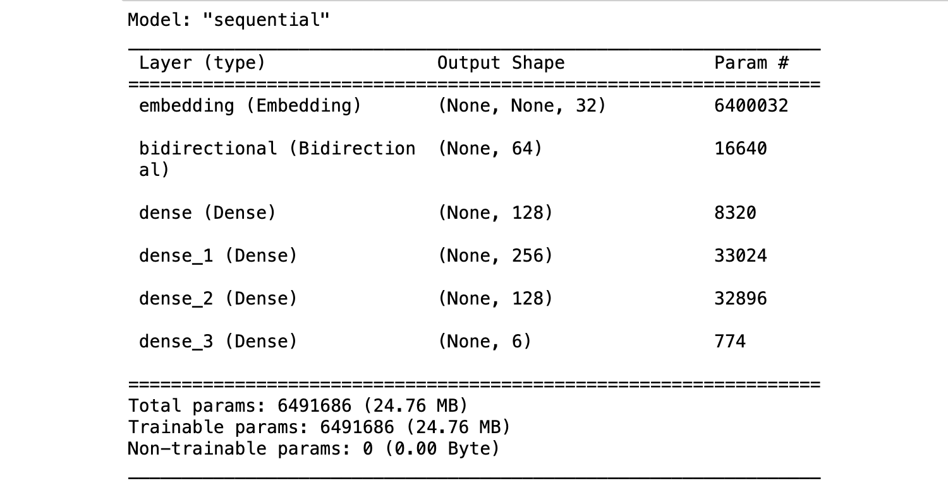

Figure 3. 1 Text Content Model Summary

# **Image Content Dataset Model**

DATA COLLECTION:

Data used for our image detection model was obtained from Facebook, a 10,000 images dataset on toxicity featuring memes users have shared. Prior to this, we explored other image sources through web scraping based on a search process using cyberbullying keywords and gathered a number of images and memes that fit the description of cyberbullying for our dataset, thus, we combine our scrapped results which we obtained from multiple web sources, some of which include: deviant, google, Pinterest, Australian Human Rights Commission website, Instagram, Twitter, etc. with the Facebook dataset and we have a slightly more robust dataset that can be used for analysis.

DATA LABELLING:

Next, we proceeded after obtaining the data, by annotating the image data by labelling them into the groups of “cyberbullying” or “not cyberbullying”, using human annotators, we categorise the images we scraped from the internet with our cyberbullying keywords. The data obtained from the Facebook Toxicity Challenge contained already labelled data and this aided our process.

DATA PREPROCESSING:

With our image data gathered, we filtered results, extracting absolutely useless content to our model building and training process and also ridding the dataset of duplicated entries. By evaluating images for standard size, quality and format, we prepared a balanced dataset. Every image in the dataset has same length and width.

FEATURE EXTRACTION:

Identifying images from the dataset to be either cyberbullying instances or not requires our model to recognize features from the data examined and so we defined features for detection that would make our predictions valid.

MODEL TRAINING:

Using Convolutional Neural Network (CNN) as our model for image content detection, we send pre-processed images to a CNN model trained on the dataset of images collected. Using CNN for image detection involves a sophisticated architecture designed to automatically learn hierarchical representations of visual data. We pass the image data to our image classifier model, which predicts what action appears in the image, to define if the action is cyberbullying or not, and then we take a prediction probability average at the end of the network using a SoftMax layer. The architecture of our CNN model consists of an input layer and an output layer, with multiple hidden layers for image computation and analysis before prediction. Our image passes through the convolutional layers and pooling layers where features are extracted before detection at the fully connected layers. We compile our model using the Adam optimiser and train the model with our already processed image dataset, splitting the dataset into testing and training batches our model should learn from.

# **Hybridization of Models- LSTM + CNN**

CNNs are great when working with image data and dealing with image classification, while LSTMs are great when working with sequences of data like series of text, but when combined, action recognition can be achieved from images and videos. Both models have been created and trained with the unique dataset media for each model, text dataset for the LSTM model and image dataset for the CNN model. While we now have two separate models, each detecting cyberbullying from either image or text content, to further enrich our model and solidify our contribution to cyberbullying detection, we unify the models into one by combining the features of both models into one. Hybridization of models is commonly practiced, in order to leverage the added advantage of two models at once, in this case, we create a hybrid model for a multimodal detection system for cyberbullying, combining the models CNN and LSTM to unify the detection process and fluidly detect cyberbullying patterns and instances from both text and images. The features of both models have been captured in 3.1. and here we explore the hybridization architecture and process.

# **Model Architecture**

The proposed model takes into cognisance, the complexities of text processing and image data processing, which influences the need for concatenation of two distinct Machine Learning algorithms. Our model deals with different modalities of data, text and image, thus, making it a multimodal model. These different data modalities are social media oriented for the purpose of detecting cyberbullying patterns when the data is analysed through the proposed model. The proposed model carries out three major processing phases: text processing, visual processing and concatenated prediction.

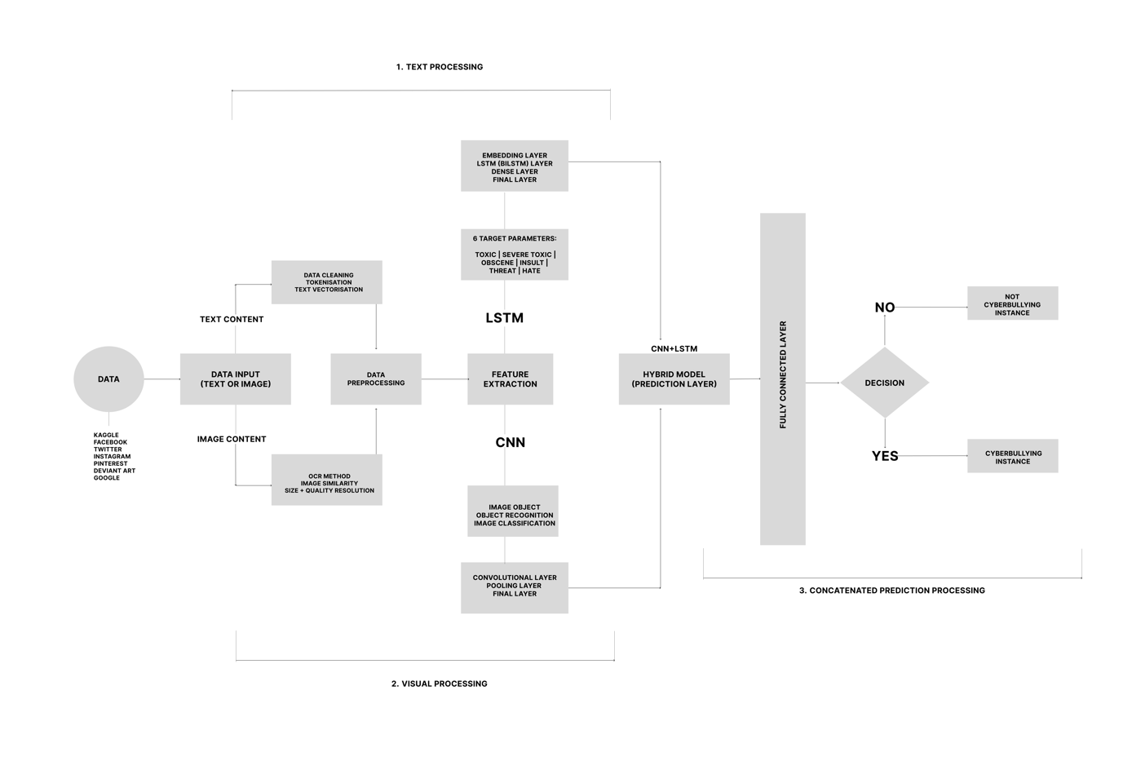

Figure 3. 2 Hybrid Model Architecture- CNN+LSTM

# **CHAPTER FOUR**

# **DATA ANALYSIS, DESIGN AND IMPLEMENTATION**

Bottom of Form

## **Data Collection**

As social media usage becomes increasingly prevalent in every age group, a vast majority of citizens rely on this essential medium for day-to-day communication. Social media’s ubiquity means that cyberbullying can effectively impact anyone at any time or anywhere, and the relative anonymity of the internet makes such personal attacks more difficult to stop than traditional bullying. The quality and quantity of the data used to train the detection model can have a significant impact on the accuracy and effectiveness of the system. The larger the dataset, the better the model trains, for our study, we utilise datasets containing 160,000 sentence samples of cyberbullying and non-cyberbullying instances and 10,000 image samples of cyberbullying and non-cyberbullying samples., thus we have a full dataset of 170,000 samples, where slightly less than 10% make up the image data and 90% of data collected is text data. This disparity shows how much less work has been done in the area of analysing image data for cyberbullying detection despite how much of cyberbullying actions have increasing become perpetuated via visual means.

Data Distribution

|  |  |  |  |
| --- | --- | --- | --- |
| Data Modality | Total Data Quantity | Cyberbullying | Non-Cyberbullying |
| Text | 160,000 | 15,294 | 144,277 |
| Image | 10,000 | 3050 | 5450 |

**Table 4. 1 Data Distribution and Categorization**

## **Data Analysis**

To analyse data collected, we performed data cleaning on the datasets, assessing data for unnecessary samples, conducting processing on text data to remove punctuations, repeated words in a sequence and double entries. We used keras deep learning library to process text data content and for the image data, we processed this. In the context of cyberbullying detection using Long Short-Term Memory (LSTM) and Convolutional Neural Network (CNN) models, we utilised the keras sequential method for the model building process after data analysis to facilitate understanding patterns and optimizing model performance. This section outlines the data analysis process, encompassing key steps taken to build and train our detection model.

## **Data Collection**

* Gathering a diverse dataset comprising text-based communication as well as images was our main focus at this point and after scouring for a fitting dataset and managing to scrape some together, we settled on the Facebook meme challenge dataset which typically fits the goal of cyberbullying detection we aimed to achieve as this dataset represents a collection of toxic and hateful memes shared across the Facebook social media platform and others just like it. Prior to final selection of the dataset, we explored cyberbullying in just text and built a model for this on completely text data obtained from Kaggle; this different dataset is a collection of 160,000 cyberbullying tweets from the twitter (X) social media application, this allowed us to compare how a model built for just text and a multimodal model would perform.
* The datasets all include labelled instances of cyberbullying and non-cyberbullying content for supervised learning, which we leveraged on for our model training process

## **Text Preprocessing**

* This marks the data pre-processing phase for our text data, we removed irrelevant characters, special symbols, and noise from the text data and then had to convert words to numeric values by tokenizing and vectorizing the text data.
* Tokenize the text into meaningful units, such as words or sub-word tokens, for input into the LSTM model, utilising the keras TextVectorization function, text input was vectorized and stored to an array of numeric values for computation. After which the dataset was cached, shuffled, divided into batches and prefetched.
* Our hyperparameters were defined in model creation phase such as the number of LSTM units which was 32 units, learning rate, and batch size of 1800 values across 6 16 batches, to ensure an optimized model.

## **Image Preprocessing**

* To preprocess the gathered image data, we conducted image analysis that involved resizing image data to 100, 100 as target size for all images and pre-processing the labels for the image data. We normalise pixel values of each image to be values between 0 and 1 for computation.
* We utilise Convolutional Neural Network for our model training, passing the pre-processed image input through two convolutional layers and two pooling layers. The conv1 is the first convolutional layer, a conv2D layer with 32 specified units and activation function as ‘relu’, after which the input passes through a poling layer and then the second convolutional layer, conv2 with 64 units and a final pooling layer and finally a flatten layer as the final image processing layer of our model. This flattened output is the layer we concatenate with the final LSTM layer from our text model in order to merge and build a hybrid CNN+LSTM model that would accept both text and image for input.

## **Mixed Methods Modelling**

A Mixed Method Research is as the name implies, it is a combination of research methods, a research approach whereby researchers collect and analyse both quantitative and qualitative data within the same study. In the cause of this thesis, this experimental research designed study utilises quantitative and qualitative approaches as it’s a thoroughly informative documentation that utilises visual data and eventually also employs numerical data to run statistical computations of the algorithms experimented. Conducting our data analysis research using Long Short-Term Memory (LSTM) + Convolutional Neural Networks (CNN) models for cyberbullying identification involved a combination of quantitative and qualitative research methods as we first analysed textual content before tokenizing and vectorizing to computational values, the same need to quantify data and represent features as numerical values for computation is applied to image data for processing.

## **Design and Implementation**

Both text and image models went through independent pre-processing and splitting and the final layers before prediction for each model is merged using the concatenate keras function to create a hybrid multimodal model for prediction. The models are merged at common dense layers for combined features and we build with text and image as inputs before compiling the final fully functional layer.

We define our loss function using categorical\_crossentropy, optimizer as Adam and metrics for evaluation is Accuracy. We now train the model with early stopping to monitor validation loss and a patience of 3 units. Fitting the model with the training datasets of text and image, specifying a batch size of 32, epochs of 20 and validation\_split of 0.2 as hyperparameters.

After training at 5 epochs courtesy of our early stopping function. We evaluate the model loss and accuracy and have the values- Loss: 0.60 and Accuracy: 0.78.

Our model is sampled for prediction and takes input as text and image after pre-processing and makes prediction, labelling input as either 1 or 0, where 1 is cyberbullying instance and 0 is not\_cyberbulling instance.

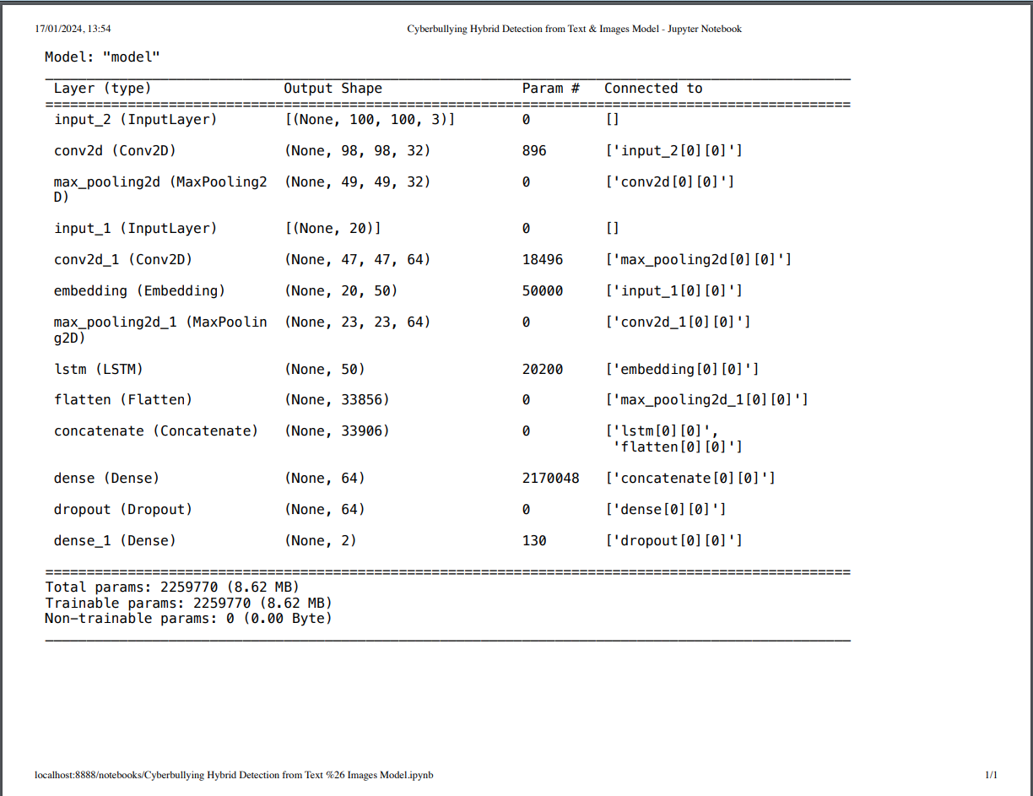

**Figure 4. 1 Multimodal Cyberbullying Detection Model Summary**

## **Deploying the Model**

One major goal of our thesis is to design and implement our model to an interactive interface where users can query the model and see predictions without necessarily making interactions with the code base. To achieve this, we utilise “Gradio”.

## **Gradio**

Gradio is a Python library that simplifies the deployment and interaction with machine learning models. It provides a user-friendly interface for creating customizable, interactive web-based interfaces to showcase and use your machine learning models. Deploying machine learning models to interactive interfaces is now a less complex demand, as gradio simply requires the function for how input should be defined and processed and an interface that does just the programmed task is generated. Our multimodal cyberbullying detection model is deployed to Gradio, capturing the text and image inputs that make our model multimodal, while specifying the preprocessing phase in our function before running prediction through the model and displaying result in the gradio interface.

Key features of Gradio include:

1. **Easy Interface Creation:** Gradio allows you to create web interfaces for your machine learning models with just a few lines of code. You can define the input components (like text boxes, sliders, or images) and the output components, making it accessible to non-technical users.
2. **Wide Range of Components:** Gradio supports various input and output components, including text boxes, sliders, images, dropdowns, and more. This enables you to create versatile interfaces that suit different types of models.
3. **Automatic Preprocessing:** Gradio handles the preprocessing of input data, making it easier for users to interact with models. It supports common data types like text, images, and videos, and it can automatically preprocess and convert user inputs into the format expected by the model.
4. **Real-time Model Updates:** As users interact with the interface, Gradio provides real-time updates, allowing users to see how the model responds dynamically.
5. **Support for Multiple Frameworks:** Gradio is framework-agnostic and can be used with popular machine learning frameworks such as TensorFlow, PyTorch, and scikit-learn.
6. **Deployment to the Web:** Gradio can deploy your machine learning interface to the web, allowing users to access it through a URL. This makes it easy to share your models with others.
7. **Open Source:** Gradio is an open-source project, providing a flexible and extensible platform that the community can contribute to and improve.

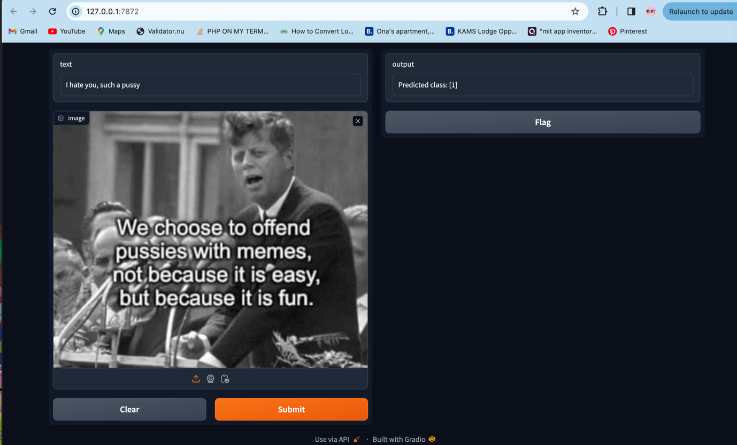

**Figure 4. 2 Gradio-Deployed Multimodal Cyberbullying Detection model**

## **Results**

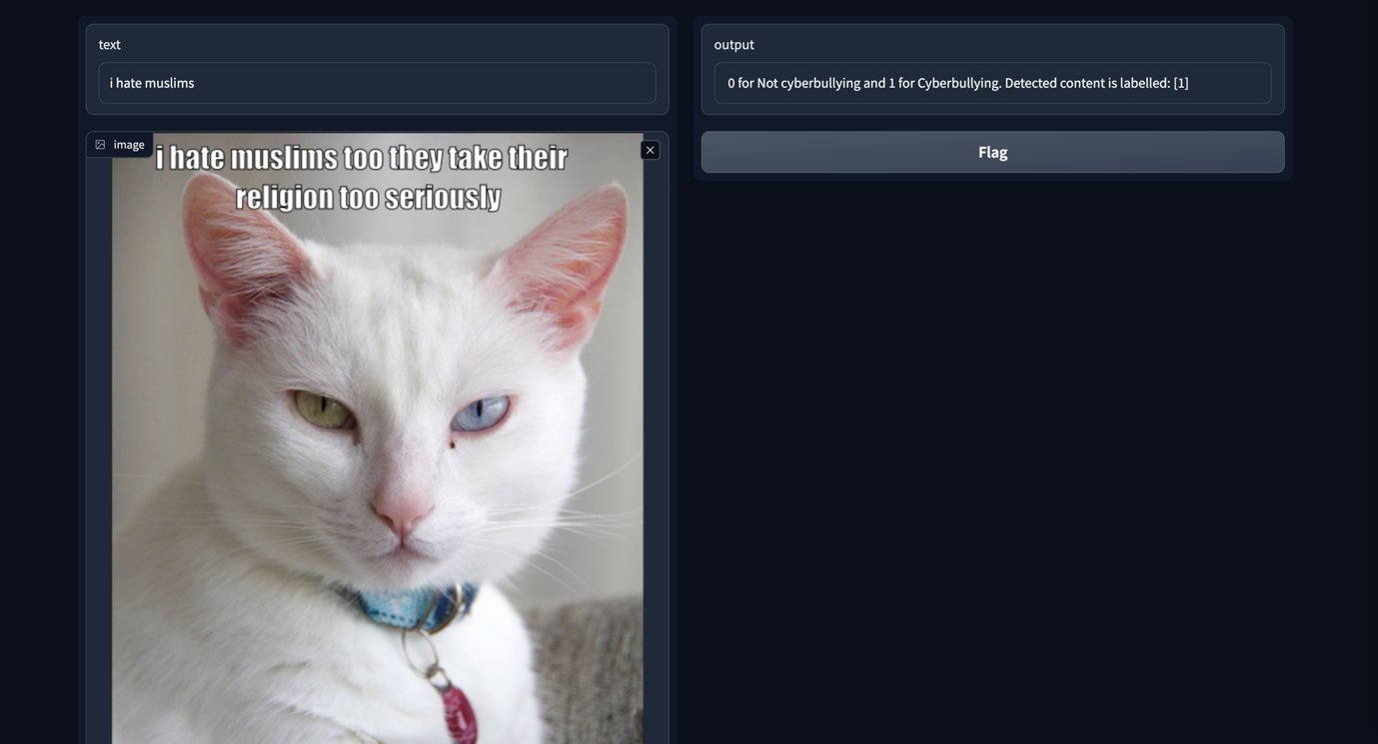

Figure 4. 3 Result of fully deployed multimodal cyberbullying detection model

Figure 4.3 shows a screenshot of the model proposed for this study being implemented showing how the image and text input together gives a prediction value that labels content as either cyberbullying or not cyberbullying.

At the end of all computation and analysis, we had built three different models in order to achieve the final result of a multimodal model. First, we built a text detection model for cyberbullying where input was only in text form utilising Long Short Term Memory model for its advantage in sequential series of data analysis and then we built an image detection model where input was simply image utilising ML’s Deep Learning Approach Convolutional Neural Network for image processing and analysis and every other image computation. Combining the strengths and advantages of both models, we merged the models to build a multimodal model that would take both inputs form the different models as input and run independent analysis on both content while m=concatenating results to give predictive output.

We discovered that the only text model had an accuracy of 0.47 and then the multimodal model had an accuracy of 0.70, this clearly indicates better performance in the multimodal model and although more training of the text model would yield better results, we fused the different models for better results at the end of the day.

# **CHAPTER FIVE**

# **CONCLUSION**

The statistics of cyberbullying is outright alarming: 36.5% of middle and high school students have felt cyberbullied and 87% have observed cyberbullying, with effects ranging from decreased academic performance to depression to suicidal thoughts. (Larxel, 2021).

The uniqueness of our contribution to cyberbullying detection is the approach to handling the multimodal characteristic of our detection model, which takes both text and image input for prediction, as well as the hybridization feature which concatenates CNN and LSTM models to create a hybrid detection model for cyberbullying. While minimal research has been conducted in multimodal forms of cyberbullying detection, we contribute to this slowly growing research area and we hybridize to present a unique solution.

To analyse and detect cyberbullying patterns from image data requires a different approach compared to detection from text data. In this endeavour, as far as we have researched, we notice how existing datasets for images on cyberbullying issues are not common or are specifically tailored to national identity like cyberbullying identification in Hindi. So, we resort to web scraping to gather images that fit the research description, this turns out to be a stringent process with a mix of favourable and unfavourable results, with the latter having higher percentage and so we delve further researching for suitable datasets. We use the Facebook Hateful Memes Challenge dataset as our image dataset and we have no hard time discovering a suitable text dataset as this has been a common research space for years.

The proposed system is a merge of Convolutional Neural Network (CNN) and Long Short Term Memory (LSTM) with Relu and Softmax activation function to detect cyberbullying instances in text and images. This is a multimodal system receiving two different media modes as input and simultaneously running analysis on both inputs to predict cyberbullying or not, this is geared towards checking all possible scenarios for cyberbullying to thrive, while this does not check every single possibility as other media modes are still means to perpetuate cyberbullying attacks, the research on images and other media forms asides text is very much scanty and more effort towards detecting cyberbullying in these other areas would to a large extent curb the menace.

Future research can be focused on a larger dataset and labelling of a more dynamic dataset of images for cyberbullying detection. More work can also be done on other forms of media like audio and video forms of cyberbullying detection. Also, a multilanguage system specifically something African or Nigerian can be explored, building a cyberbullying detection system that detects cyberbullying instances from text in pidgin, would be influential in addressing cyberbullying concerns in Nigeria or around pidgin-speaking social media population, as such a system would directly engage even local forms of cyberbullying on social media with Nigerian social media as case study. Of course, with all of these future work recommendations, data availability will prove to be the major challenge and as such more work on data gathering for ML researches like this that requires tons of data for accuracy leverage needs to be conducted to minimise research limitations.

In summary, our findings from this research suggest that more cyberbullying scenarios can be explored for better chances to curb the growing cyberbullying problem on social media, which is why we make the aforementioned recommendations for future research and work on the area.

# References

Aune, N. (2009). Cyberbullying. Graduate School of Wisconsin- Stout.

(2015). Challenges and opportunities for use of social media in higher education. Journal Learning for Development. JL4D. Vol 6(1).

Brown, S. (2021). Social media is broken, a new report offers 25 ways to fix it. Ideas Made to Matter.

Buan & Ramachandra (2020). Automated cyberbullying detection in social media using an SVM activated stacked convolution LSTM network. International Conference in Computer and Data Analysis. <https://doi.org/10.1145/3388142.3388147>

Chen, Y., Liu, J., & Chen, X. (2021). Cyberbullying Auto-Identification on Social Media Using Long-Short Time Memory. IEEE Access, 9, 108937-108947. doi: 10.1109/ACCESS.2021.3101168

Dwivedi et al. (2021). Setting the future of digital and social media marketing research: perspectives and research propositions. International Journal of Information Management Visa.

Fathima, R. Z., & Rajesh, R. (2021). Cyberbullying Auto-Identification on Social Media Using Long-Short Time Memory. In Advances in Computer Communication and Computational Sciences (pp. 155-163). Springer.

Gámez-Guadix, M., Orue, I., Smith, P. K., & Calvete, E. (2013). Longitudinal and reciprocal relations of cyberbullying with depression, substance use, and problematic internet use among adolescents. Journal of Adolescent Health, 53(4), 446-452.

Graves, A. (2012). Supervised sequence labelling with recurrent neural networks. Springer.

Greff, K., Srivastava, R. K., Koutník, J., Steunebrink, B. R., & Schmidhuber, J. (2017). LSTM: A search space odyssey. IEEE transactions on neural networks and learning systems, 28(10), 2222-2232.Hinduja, S., & Patchin, J. W. (2018). Cyberbullying: An update and synthesis of the research. In Handbook of bullying in schools (pp. 249-262). Routledge.

Hinduja, S., & Patchin, J. W. (2018). Cyberbullying: An update and synthesis of the research. In Handbook of bullying in schools (pp. 249-262). Routledge.

Hochreiter, S., & Schmidhuber, J. (1997). Long short-term memory. Neural computation, 9(8), 1735-1780.

Holt, M. K., Vivolo-Kantor, A. M., Polanin, J. R., Holland, K. M., DeGue, S., Matjasko, J. L., & Reid, G. (2015). Bullying and suicidal ideation and behaviors: A meta-analysis. Pediatrics, 135(2), e496-e509.

Hosseinmardi, H., Mattson, S.A., Rafiq, R.I., Lv, Q. & Mishra, S. (2015). Detection of Cyberbullying Incidents on the Instagram Social Network.

J. Wang, K. Fu, C.T. Lu, “[SOSNet: A Graph Convolutional Network Approach to Fine-Grained Cyberbullying Detection](https://ieeexplore.ieee.org/document/9378065" \t "_blank),” Proceedings of the 2020 IEEE International Conference on Big Data (IEEE BigData 2020), December 10-13, 2020.

Kowalski, R. M., Giumetti, G. W., Schroeder, A. N., & Lattanner, M. R. (2014). Bullying in the digital age: A critical review and meta-analysis of cyberbullying research among youth. Psychological bulletin, 140(4), 1073.

Kowalski, R. M., Limber, S. P., & Agatston, P. W. (2012). Cyberbullying: Bullying in the digital age. John Wiley & Sons.

Kowalski, R. M., Giumetti, G. W., Schroeder, A. N., & Lattanner, M. R. (2014). Bullying in the digital age: A critical review and meta-analysis of cyberbullying research among youth. Psychological Bulletin, 140(4), 1073-1137.

Lane, M. & Coleman,P. (2012). Technology ease of use through social media networking. Journal of Technology Research.

Larxel. (2021). Cyberbullying classification. Kaggle Data Bank.

Lee, J. J., Park, J., Moon, H., & Cho, J. (2019). A survey of cyberbullying detection using machine learning and data mining techniques. IEEE Access, 7, 23512-23523.

Liang, X., Zhang, Y., Lin, X., Chen, H., & Huang, X. (2020). Cyberbullying Auto-Identification on Social Media Using Long-Short Time Memory. IEEE Access, 8, 157932-157944. <https://doi.org/10.1109/ACCESS.2020.3019995>

Mishra, S., & Mishra, A. (2019). Cyberbullying detection using machine learning algorithms: A review. Journal of Ambient Intelligence and Humanized Computing, 10(1), 1-17.

Mishra, S., Nath, S., & Sharma, S. (2021). Classification of cyberbullying comments on Instagram using deep learning. Journal of Ambient Intelligence and Humanized Computing, 12(7), 6625-6636

Olweus, D. & Limber, S. (2017). Some problems with cyberbullying research. Current Opinion in Psychology. DOI: 10.1016/j.copsyc.2017.04012.

Patchin, J. W., & Hinduja, S. (2016). Cyberbullying and self-esteem. Journal of School Health, 86(5), 380-387.

Patchin, J. W., & Hinduja, S. (2020). Preventing Cyberbullying: Ten Tips for Educators. Cyberbullying Research Center. https://cyberbullying.org/preventing-cyberbullying-ten- tips-for-educators

Patchin, J. W., & Hinduja, S. (2018). Cyberbullying: Identification, prevention, and response. Routledge.

Salawu, S. D. (2021). Detection and Prevention of Cyberbullying on Social Media. Doctoral dissertation, Aston University.

Tufekci, Z. (2018). Social media and the decision to participate in political protest: Observations from Tahrir Square. Journal of Communication, 62(2), 363-379.

Zhang, Y., Luo, B., & Wang, Y. (2018). Cyberbullying detection on Twitter using traditional machine learning and deep learning approaches. In Proceedings of the 27th International Conference on Computational Linguistics: System Demonstrations (pp. 13-17).

Zhu, C. et al. (2021). Cyberbullying among adolescents and children: A comprehensive review of the global situation risk factors and preventive measures. Frontiers in Public Health.

# **APPENDIX**

**Appendix A**: Data Utilised

**Appendix B**: Technologies Exploited

**Appendix C**: Implementation & Results

## **Appendix A: Data Utilised**

In the course of this study, data had to be analysed and computed to make predictions. This data was necessary for the model to learn from, in order to make predictions from test inputs. Data was collected from different sources and by two means. The major means of data collection was relying on existing data libraries like Kaggle and large trustworthy bodies like Meta. We collected data for training our preliminary cyberbullying detection from text model from Kaggle and then collected data for training our cyberbullying detection from images model from Meta Facebook Hateful Memes Challenge.

The Kaggle data can be found at this link: <https://www.kaggle.com/c/jigsaw-toxic-comment-classification-challenge/data>

The Meta data can be found here: <https://www.kaggle.com/datasets/parthplc/facebook-hateful-meme-dataset/data>

DATA SUMMARY

|  |  |
| --- | --- |
| **Subject** | Cyberbullying, Cyberbullying Detection, Psychology, Social Media, User Engagement, Machine Learning |
| **Specific Subject Area** | Data Analysis, Big Data, Cyberbullying Analysis and Detection, Classification Techniques, LSTM, CNN, Multimodal Detection, Model Hybridization |
| **Type of Data** | Data Files in (.csv, .jsonl, .png) |
| **Data Acquisition** | Online data bank (Kaggle), web scraping and Meta Facebook |
| **Data Format** | Raw |
| **Parameters of Data Collection** | Cyberbullying instances. Data collected had to be classified into cyberbullying patterns and not cyberbullying patterns |
| **Data Accessibility** | Upon Request. |

Below are pictorial representations of our data collected and utilised.

A)

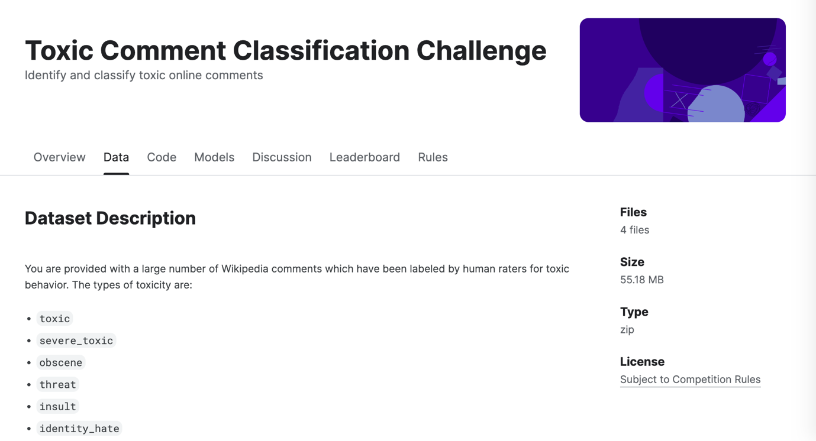

B)



C)

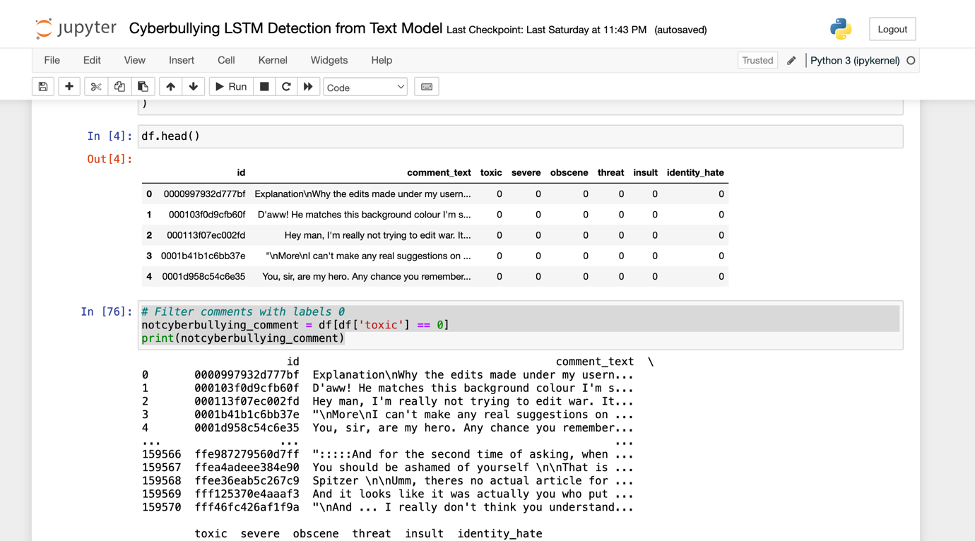

D)

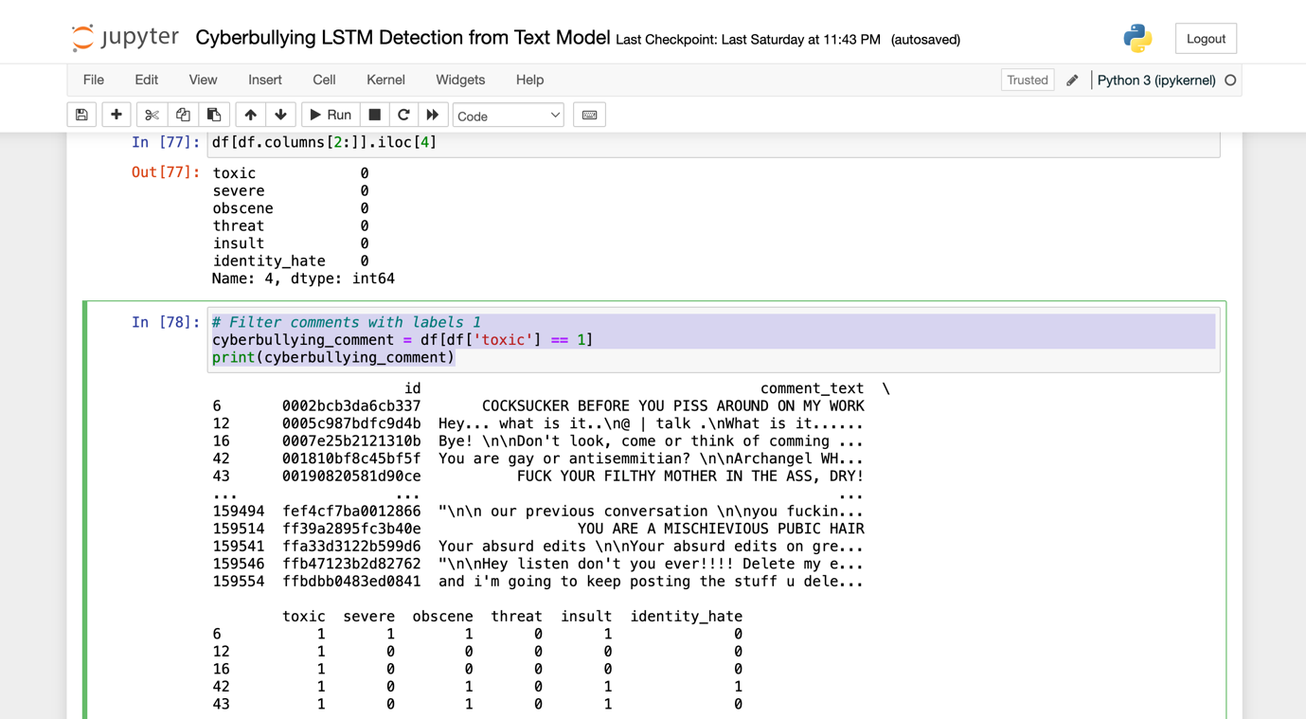

E)

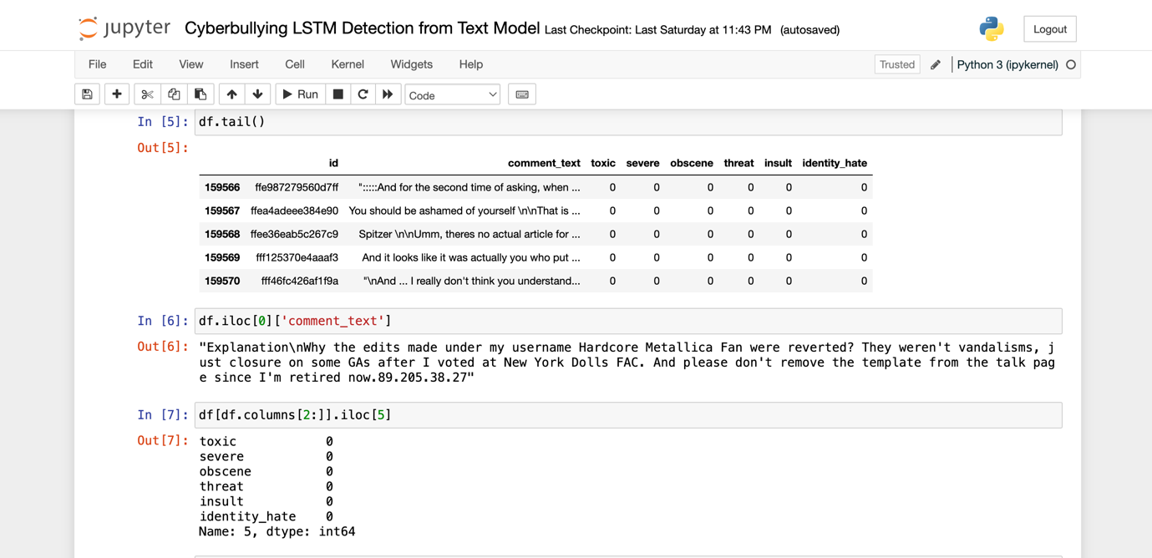

F)



G)

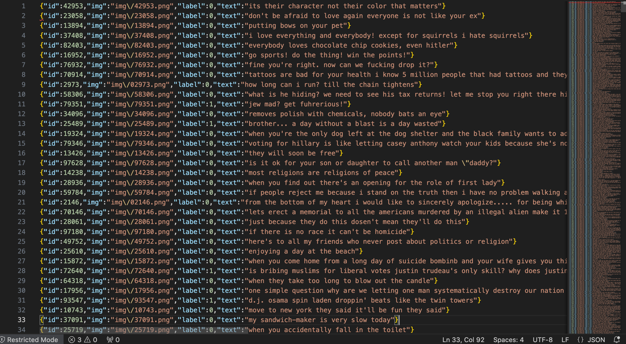

H)

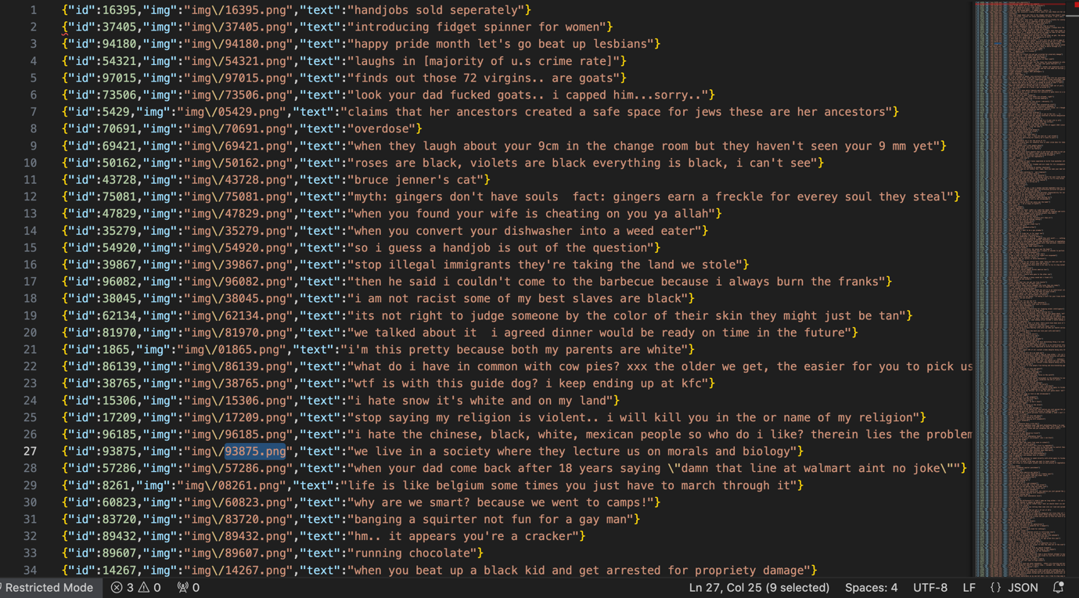

I)



J)

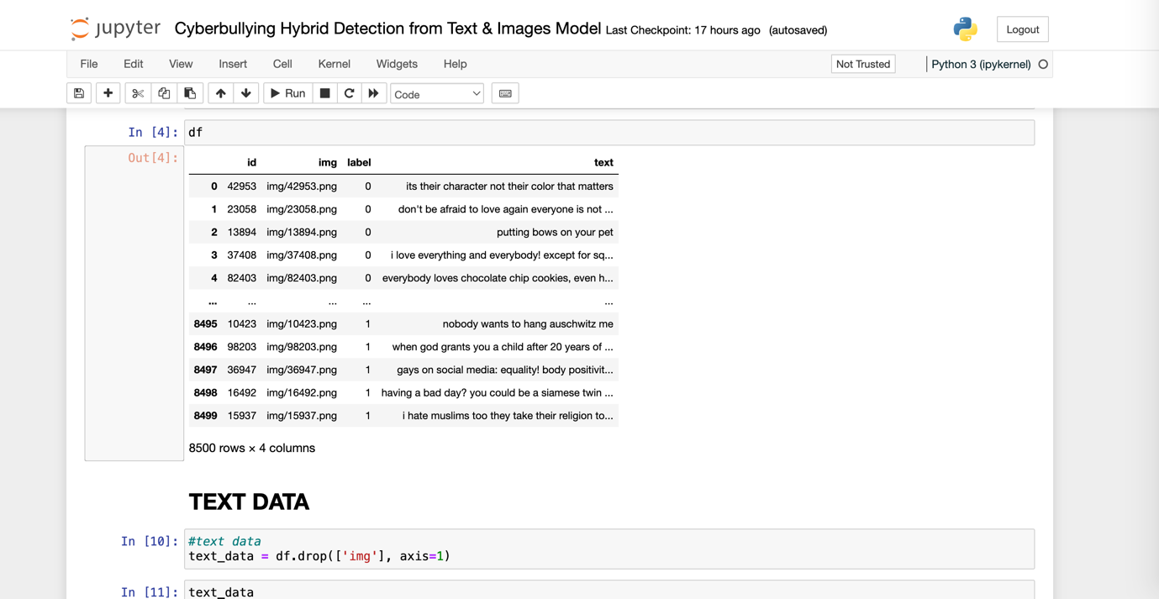

## **Appendix B: Technology Exploited**

In the course of conducting this study and building our cyberbullying detection models, from inception of the research process till finish, we utilised a good number of technologies listed below.

* 1. KAGGLE: Data library we source our cyberbullying datasets from.
  2. WEB SCRAPING EXTENSION- DOWNLOAD ALL: Google chrome extension, we utilise to download a whole page of cyberbullying instances.
  3. EXCEL: Microsoft Excel file to open .csv extension files and view data.
  4. VISUAL STUDIO CODE: IDE we used to open and view .json files from the Meta Facebook Hateful Memes dataset.
  5. ANACONDA: Anaconda is a distribution of open-source tools and frameworks for data science, machine learning, and scientific computing. It includes popular programming languages like Python and R, along with pre-installed packages and libraries, making it a comprehensive and easily manageable platform for data science projects. We utilised Anaconda to run our python files using Jupyter notebook in the Anaconda environment.
  6. JUPYTER NOTEBOOK: Jupyter Notebook is an open-source interactive web application that allows users to create and share documents containing live code, equations, visualizations, and narrative text. We utilise this application for scripting our python codes and basically run our build, train and run our models here.
  7. GRADIO: This is another open-source technology and it is a python library for creating user interfaces to deploy and interact with machine learning models. It simplifies the process of building interactive web interfaces, enabling easy sharing and usage of models without extensive web development. We utilise gradio to deploy our models to an interactive web interface locally hosted and can be publicly shared.
  8. LSTM: Long Short-Term Memory (LSTM) is a type of recurrent neural network (RNN) architecture designed for learning long-term dependencies in sequential data. We utilised the LSTM model to build our cyberbullying detection from text model and basically handle the text channel in our multimodal detection model.
  9. CNN: Convolutional Neural Network (CNN) is a class of deep neural networks designed for pattern recognition in visual data like images. CNNs use convolutional layers to automatically learn hierarchical features and are widely applied in image classification, object detection, and image analysis tasks. We utilised the CNN model to build our cyberbullying detection from images model and basically handle the image channel in our multimodal detection model
  10. FIGMA: Figma is a collaborative web-based design and prototyping tool. We utilised Figma to design our model flow architecture.

## **Appendix C: Visuals of Implementation & Results**

